Project Proposal

*WhaleWise.ca*

Reducing Ocean Noise Pollution in BC Waters for Orca Population

In response to Ocean Networks Canada request for proposals: ONC RFP# 202301: “Client-Specific Dashboard Design for Marine Science Data” [1].

By: Pedro Augusto Gonçalves Gomes Amaral,

Parker DeBruyne,

Justin Eng,

& Hayden Dunstan

For: Dr. Dave Riddell,

Ocean Networks Canada,

Post-Secondary Education Coordinator

April 06, 2023



WhaleWise.ca

April 06, 2023  
  
Dr. Dave Riddell, PhD BEd  
Post-Secondary Education Coordinator  
Environmental Scientist, Ocean Networks Canada  
  
Dear Dr. Dave Riddell:

We ask you to consider and accept the attached report in response to your request for proposals for Dashboards that educate the public and protect marine life (ONC RFP# 202301).

Thanks to our research, this document describes the functionalities of a solution that not only addresses the problems outlined in the RFP but also promotes real, actionable, change within the community. It uses ONC data with AIS ship tracking and provides a simple solution to a complex problem by creating a better relationship between sea life and human activity. The most cost-effective solution we found involves slowing down ships near areas of orca activity.  
  
We would like to thank Kate Skipsey—our project coordinator—who introduced us to this project and provided invaluable mentoring throughout the project. We would also like to thank both Jasker Kanes—Jr. marine scientist at ONC— and you, Dr. Dave Riddell, for the insight that helped shape, direct and develop this project.  
  
Sincerely,  
Pedro Amaral, Parker DeBruyne, Justin Eng, Hayden Dunstan.

Attachment: Reducing Ocean Noise Pollution in BC Waters for Orca Population

**Table of Contents**

**Executive Summary 1**

**1. ONC’s Goal 2**

1.1 Orcas and Noise Pollution 2

1.2 Solution objectives and constraints 3

**2. Proposed Solution 3**

2.1 Solution Overview 3

2.2 Design and Layout 4

2.3 Solution Functionalities 5

2.4 Design Process 6

2.5 Solution Effectiveness 6

[**3. Project Plan and Timeline 9**](https://docs.google.com/document/d/1JTvOvW7JPlepseOy8ZcEEM5chQmxdAYRjdOxH1p0S24/edit#heading=h.xq4e02uprgeh)

3.1 Completed Tasks 9

3.2 Project Cost and Timeline 9

**4. Team Credentials 10**

4.1 Pedro Augusto Gonçalves Gomes Amaral 10

4.2 Parker DeBruyne 10

4.3 Justin Eng 10

4.4 Hayden Dunstan 10

**5. Request for Permission 10**

**6. References 11**

**Appendices 13**

Appendix A: Work Logs 13

Appendix B: Weighted Objective Chart Rubric 14

Appendix C: Team Charter 14

**List of Tables and Figures**

**Figure 1:** Orca Population vs. Time………………………………………………………………………………..….2

**Figure 2:** 2021 Orca Sightings in the Strait of Georgia…………………………………...…………………………..2

**Figure 3:** Ferry Ship Paths in the Strait of Georgia, AIS ship-tracking…………………….…………………………2

**Table 1:** Problem Definition of Noise Pollution and BC Orca Population……………………………………………3

**Figure 4:** Landing section of WhaleWise.ca…………………………………………………………………………..4

**Figure 5:** Visual representation of the Live Map……………………………………………………………………...5

**Figure 6:** The landing page of whalemap.org………………………………………………………………………....6

**Figure 7:** The landing page of exhibit.ocearch.org……………………………………………………………………7

**Table 2:** Weighted Objectives Chart Comparing Similar Applications……………………………………………….7

**Figure 8:** Spring 2023 Work Plan Gantt Chart……………………………………………………………………...…8

# Executive Summary

Ocean Networks Canada (OCN) desires software solutions that aid in their efforts to inform the public on ecosystem health and mitigate the harmful effects of noise pollution on orca populations through the use of their online Dashboards.

This document proposes the development of a website that helps captains lower their speeds to safe levels when close to orca pods and thereby to reduce their noise impact on marine environments. This decision bases itself on the fact that ships produce some of the largest auditory threats to ocean life, so even small reductions in speed significantly dampen harm.  
  
Using hydrophone data from ONC and live AIS ship tracking, our solution notifies all ships in a certain region—those frequented by orca pods—when decibel levels become too high. Furthermore, we included educational sections for the public in our designs and a call for legislation where visitors can email members of parliament. Through an extensive analysis of alternatives, we identified WhaleWise.ca as the most cost efficient and effective solution.

# 

# 1. ONC’s Goal

Ocean Networks Canada (ONC)—owned by the University of Victoria (UVic)—manages a cabled network of observation equipment along Canadian coastlines and the deep sea which collect and distribute earth and ocean data to researchers and the public. They pride themselves on maintaining positive relations with coastal communities and providing solutions to ecological challenges.

## 1.1 Orcas and Noise Pollution

Orcas currently amount to dangerously low numbers—one of the lowest population rates seen in over 20 years, **Figure 1**. When they hunt in British Columbia, **Figure 2**, they encounter noise pollution from ferries and freight ships, **Figure 3**. This distorts their echolocation and

undermines their ability to find food, socialize, and coordinate as a pod [5]. For our task,

we focused on the Strait of Georgia—a water highway off the port of Vancouver used

for commercial ships and a local hotspot for orca activity, **Figures 2 & 3**.

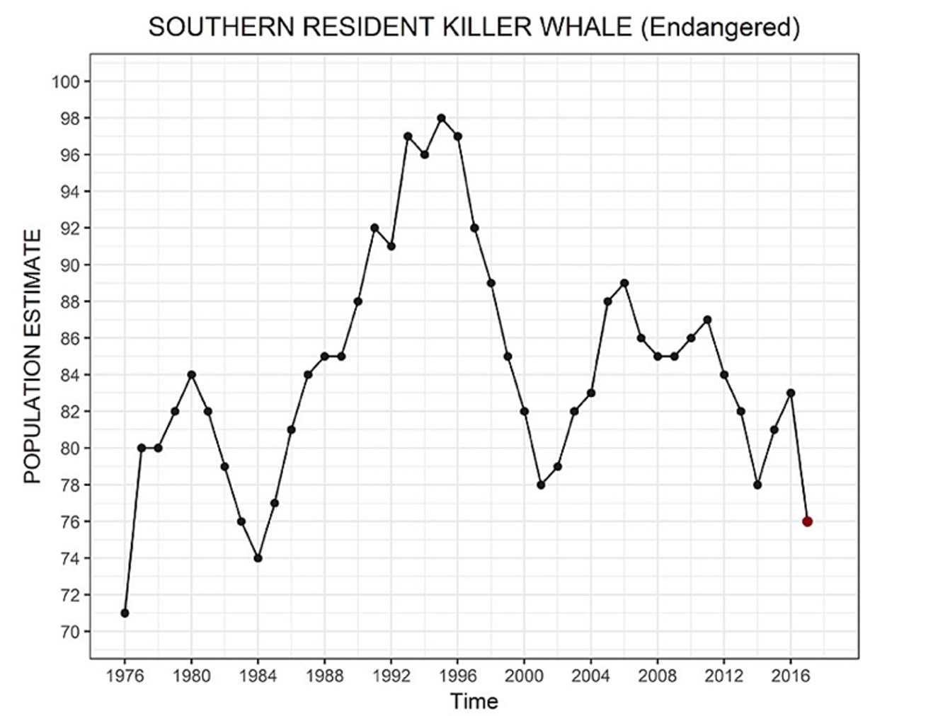

**Figure 1:** Orca Population vs. Time, adapted from [2].

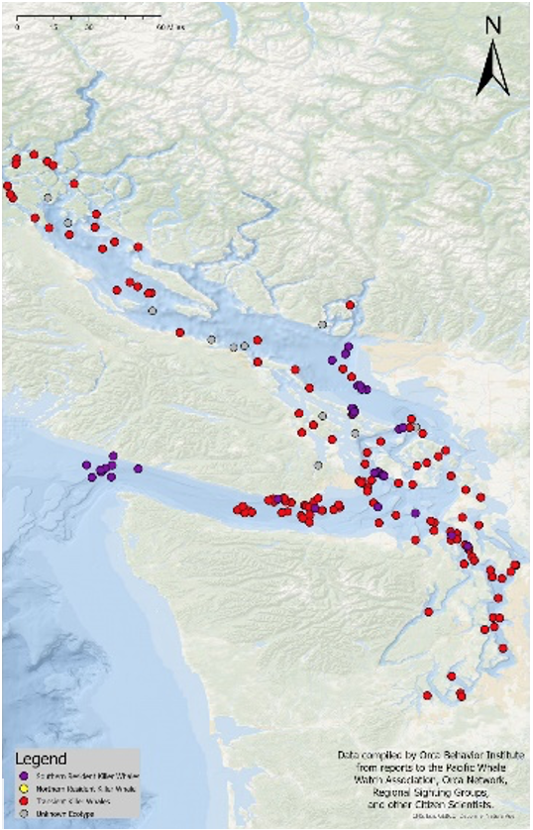

**Figure 2:** 2021 Orca Sightings in the Strait of Georgia, adapted from [3].

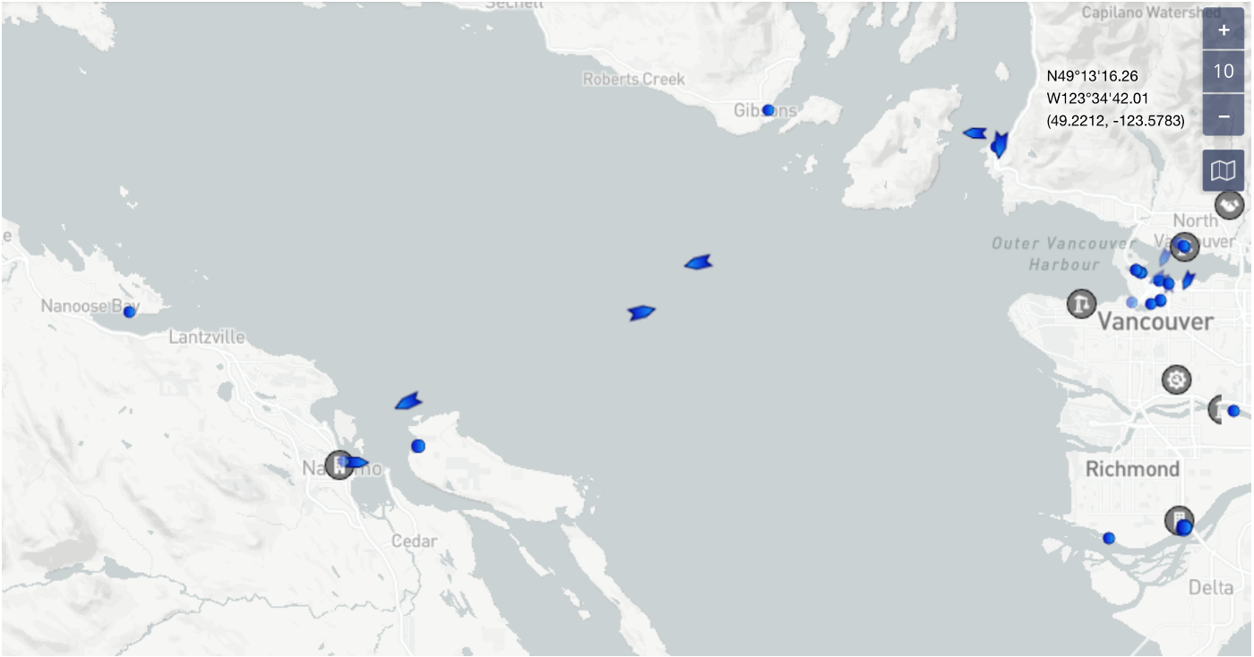

**Figure 3:** Ferry Ship Paths in the Strait of Georgia, AIS ship-tracking, adapted from [4].

## 1.2 Solution objectives and constraints

Table 1 outlines the client's problem as detailed in the RFP[1].

**Table 1. Problem Definition of Noise Pollution and BC Orca Population**

| **Need** | ONC would like an immersive dashboard that explores the negative effects of noise pollution on the BC orca population |
| --- | --- |
| **Goal** | The Dashboard should achieve the following:   * Useful for captains of large vessels to help them reduce noise pollution and harm to Orca populations * Inform and educate the general public and policy makers on the threat that noise pollution poses to the BC orca populations * Viewers should feel sympathetic and motivated to help |
| **Objectives** | The proposed solution should aim for these objectives:   * Intuitive to use * Reduces marine noise pollution * Educates the public on how noise pollution interferes with orca echolocation * Includes a section explaining how the general public can help |
| **Constraints** | The proposed solution must abide by these hard constraints   * The dashboard uses language that can suit a larger audience ie. absent of foul-language and includes explanations of large scientific words. * The experience uses real data and does not falsify information * Does not break any laws, including but not limited to copyright infringement, plagiarism, and animal abuse. |

# 

# 2. Proposed Solution

We brainstormed several ideas after reading the RFP and tested their feasibility by talking with an ONC scientist, Jasper Kanes [5, 6]. We confirmed commercial ships as the largest source of marine noise pollution in the Strait of Georgia and targeted Ship Captains as our primary user base. After adding Justin and Hayden to our group, we decided to expand our dashboard idea to incorporate aspects geared towards researchers and the general public.

## 2.1 Solution Overview

Our dashboard design combines existing technologies such as live AIS Ship Tracking (similar to **Figure 3**) [7], live decibel readings from ONC hydrophones, and a predictor of killer whale hotspots using ONC data and widget APIs. These widgets mix to create a live map for captains. This map calculates the ship’s proximity to hotspots and recommends a safe speed to produce less sound. The dashboard includes an educational section detailing the effects noise pollution has on the BC orca population and a section that encourages and facilitates users to contact their MPs about the issue. A mobile version of the dashboard has the ability to send notifications to captains should they need to slow down.

## 2.2 Design and Layout

New users first discover a search bar and an informative tagline when visiting [www.whalewise.ca](http://www.whalewise.ca), **Figure 4**. After selecting their ship’s name from a dropdown box, the section transitions to a map centered around the vessel, **Figure 5**. From the map display, the viewer sees the current speed and path of the ship. When hydrophones detect elevated sound levels, each ship within a certain radius receives a notification to slow down—which displays as an overlay notification on top of the map section. Users can search for any ship through this web app, but captains may also login through the menu options in the top right and receive push notifications to their satellite phone. Clicking the logo takes viewers back to the homepage to search again. This section provides users with actionable feedback on their ship’s speed when it comes to reducing marine noise pollution and protecting vulnerable marine life.

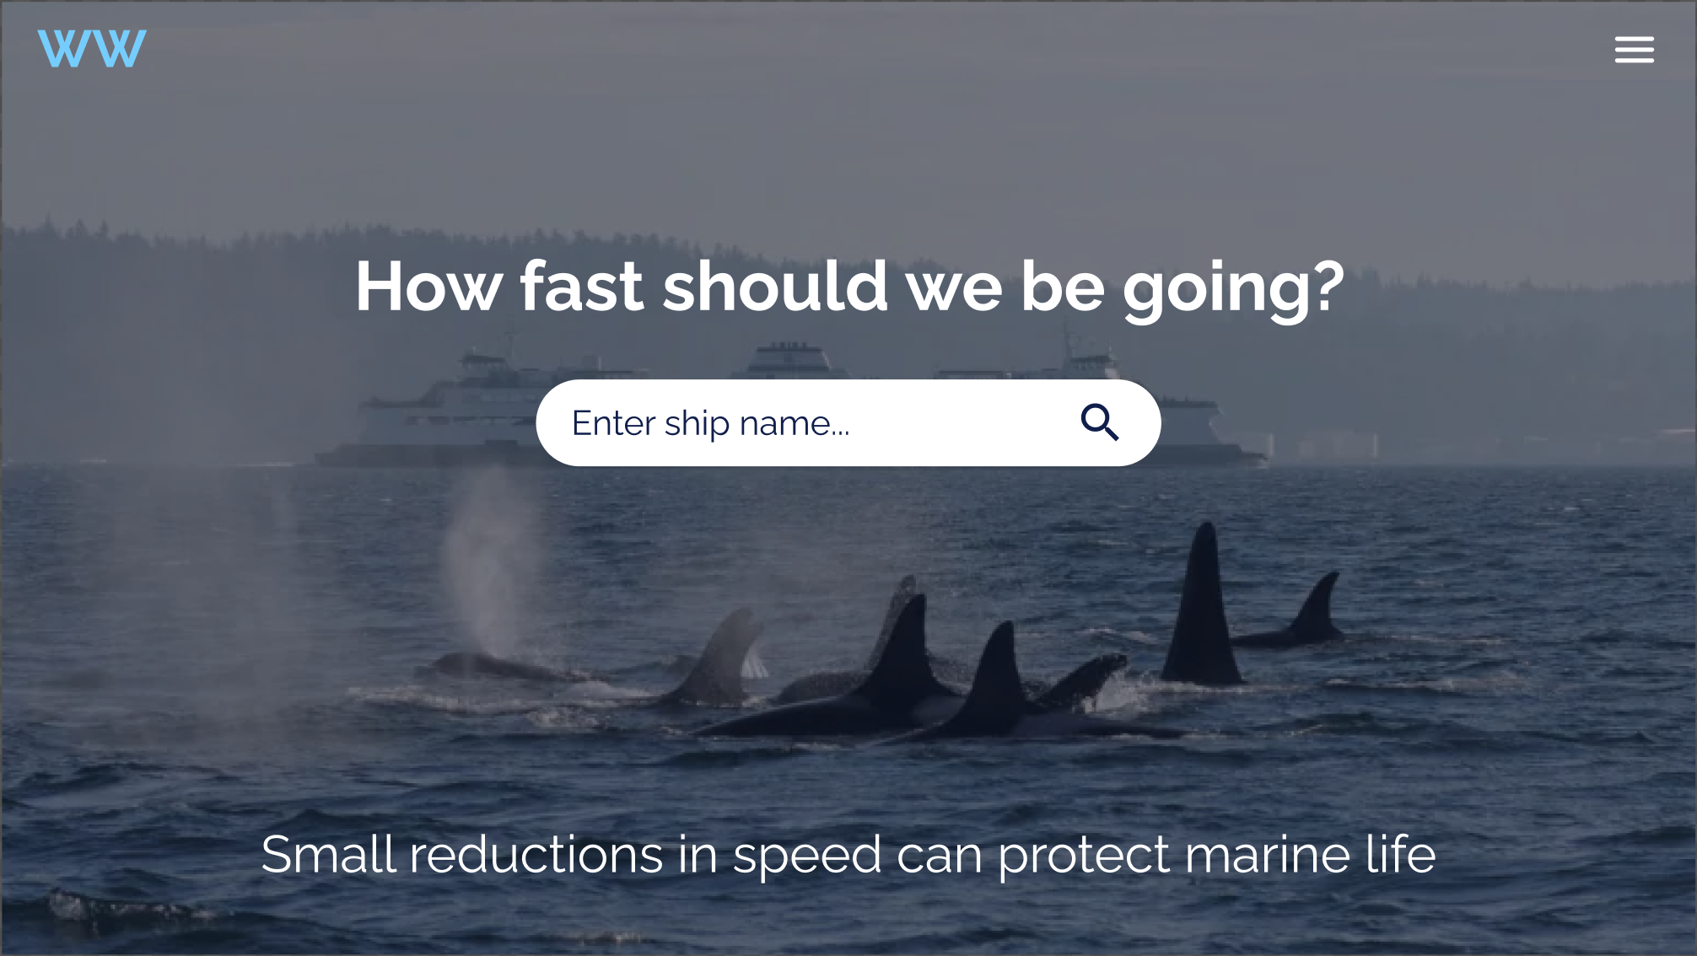

**Figure 4:** Landing section of WhaleWise.ca

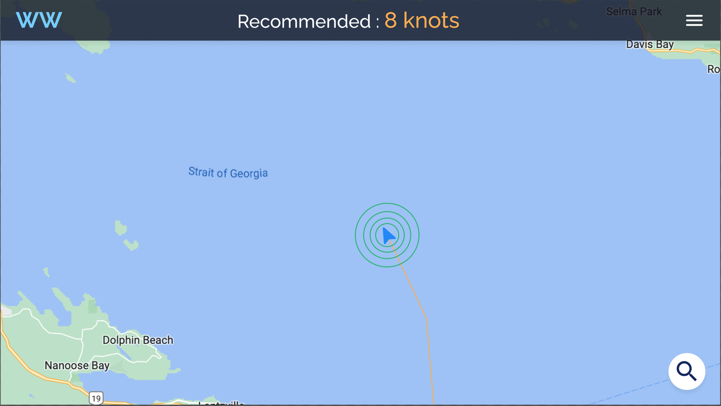

**Figure 5:** Visual representation of the Live Map

## 2.3 Solution Functionalities

Using ONC data, the website estimates zones of high orca activity—called Orca Areas—which stay hidden from the general public but viewable to researchers through a special login. The map displays a visual representation of any ship’s sound field, which changes in size based on its speed. A speed recommendation resides at the top of the map and adjusts itself based on proximity to Orca Areas, hydrophone readings, and the ship’s weight class and engine.

Below the landing section, users find educational charts and facts explaining the detrimental effects of marine noise pollution on orca echolocation; ONC supplies data for these charts through widget API handles, and a time-series graph displays trends in orca populations vs. decibel readings in BC waters. These graphics teach visitors about the consequences of marine noise on local ecosystems and motivates them to carry on the next section.

At the end of the page, visitors see a final section that sends a message to their local member of parliament upon completion. They fill out entry-boxes for their name, area code, and a pre-typed message before hitting the submit button. A database uses the area code to find the closest member of parliament in the users region, and the message explains how the lack of marine noise pollution regulatory law contributes to the issue. Furthermore, the message suggests a potential solution rather than merely stating a problem: recent advances in engineering have yielded toroidal propellers which reduce noises significantly, [9, 10]. After passing legislation, parliament could charge a fine on loud ships, waive the fee if ships transition to toroidal propellers, and use the funds towards marine conservation—the pre-typed message explains all of this, but users may edit it before submitting the email.

## 2.4 Design Process

Enterprise Design Thinking is the strategic approach where the client’s needs are central to the design process [8]. Cycling between brainstorms and client interviews creates iterations of prototypes which are tested and continually improved. This approach to design encourages collaboration between the user and designer to co-create a solution that best fits the client’s true need. Our project used Enterprise Design Thinking in order to create a product that users find beneficial and also enjoyable. Below lists the steps involved in our design process:

1. Defined the problem (Outlined in the RFP [1])
2. Identified potential users
3. Brainstormed potential solutions
4. Interviewed client [5]
5. Updated designs
6. Form MVP (minimum viable product) [11]
7. Pitch to client

We believe that following this design philosophy not only improved our design’s effectiveness on noise pollution, but also identified an enjoyable experience for users.

## 2.5 Solution Effectiveness

We compared our proposed solution with two different marine animal tracking websites: whalemap.org, and Ocearch.org, **Figures 6 & 7**. We chose these two because both websites pinged the rough location of their respective animal of choice. We decided to remove the locations of the pings from our solution based on the potential consequences of showing the location of orcas and increasing whale-watching traffic.

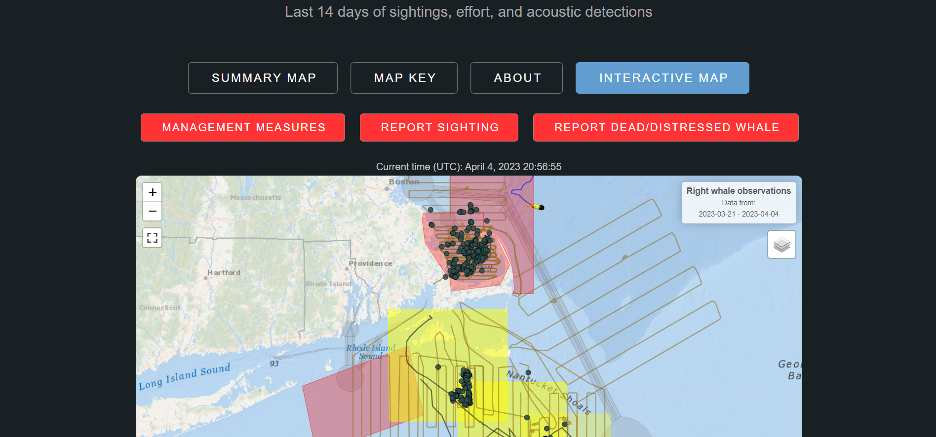

**Figure 6:** The landing page of whalemap.org. Adapted from [12].

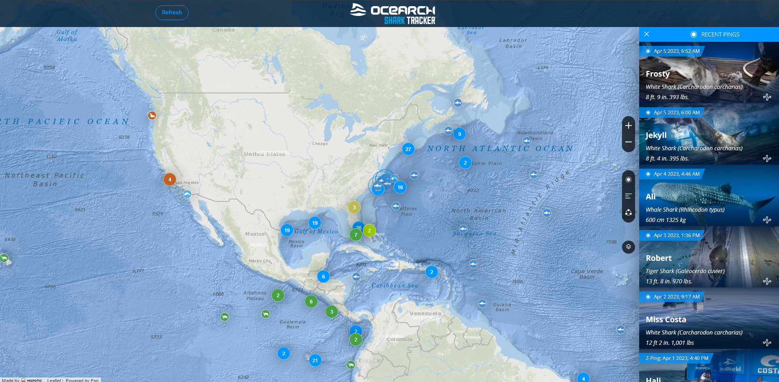

**Figure 7:** The landing page of exhibit.ocearch.org. Adapted from [13].

**Table 2. Weighted Objectives Chart Comparing Similar Applications**

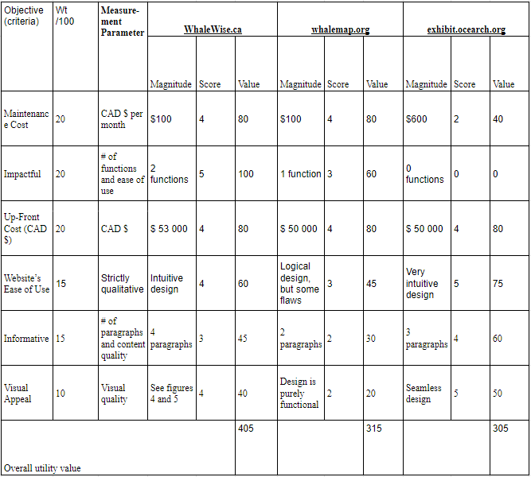

We estimated the cost of each website—both up front and monthly—and determined the estimated costs involving factors such as, but not limited to, drone/vehicle maintenance, employee salaries, legal fees, web domain subscription, and instrument upkeep [13].

# 3. Project Plan and Timeline

After all of our research, the team felt the need to both present some of the work we have already performed and give an estimated time frame and cost for the development and implementation of this project. This will show how seriously the team has considered actual implementation of the project, and our confidence in its potential.

## 3.1 Completed Tasks

Our team completed four tasks so far in our project. A draft of this report, a presentation plan for our client report, the actual client report, and a reflection memo. Our Gantt Chart for these tasks (Figure 8) describes their time frames and the work put into them.

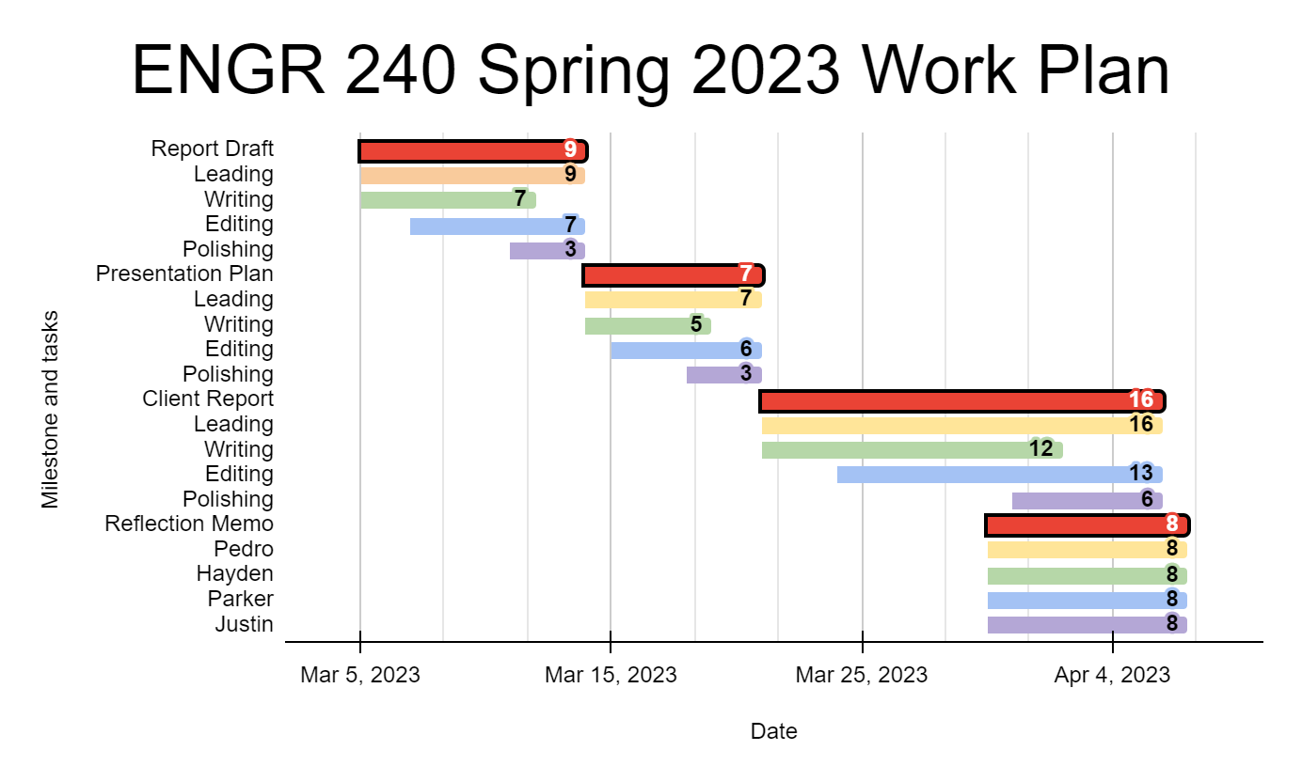

**Figure 8:** Spring 2023 Work Plan Gantt Chart

## 

## 3.2 Project Cost and Timeline

We estimate that we can finish this project in 6 months with 2 people consistently working full time, 40 hours per week. According to Indeed [15], the average salary for a web developer in Canada is $4966 per month, adjust for the fact that we consider ourselves entry level employees and that comes to an estimated labor cost of $3200 per month*2 people*over 6 months = $38,400. Our project uses existing technology and would therefore only additionally require the legal fees of hosting a website, and any unforeseen costs, total estimated at $5000. That all adds to an estimated total cost of $43,400.

# 4. Team Credentials

Here follows a quick description of our team members and their background, highlighting the reasons we feel confident in delivering on the ideas presented throughout this proposal.

## 4.1 Pedro Augusto Gonçalves Gomes Amaral

A Computer Science student at UVic, Pedro excels at programming and software design through his experience with video games. His background brings insight into the user experience and guides the interview and research process.

## 4.2 Parker DeBruyne

Parker studies Computer Science & Health Informatics at the University of Victoria and develops websites with his friends. He gained design experience through a tech start-up program at UVic called INSPIRE and aims to operate a tech company one day.

## 4.3 Justin Eng

Justin’s experience as UVic badminton club’s president and UVic FPS club’s executive build upon organizing and managing skills. Additionally, his passion for Computer Science and love of sports form the foundation for his objective reasoning and problem solving skills. Justin’s background emphasizes critical thinking, professionalism, and flexibility.

## 4.4 Hayden Dunstan

Hayden worked several jobs in the customer service industry and, as a result, has a strong client focused approach. This experience, in addition to his computer science background, gives a useful perspective on the client usage aspect of this project.

# 5. Request for Permission

If our project is accepted, its design will provide the following: (1) a live map for captains with speed recommendations, (2) visuals and charts to educate the public on echolocation and noise pollution, (3) a method of contacting Members of Parliament to push for decibel regulation, and (4) donation links to related charities.

We believe that ONC data can be combined with existing technology to create an educational experience for the public and make a positive impact on BC marine life. To that end, we request permission and funding to further our research based on the presented ideas.

We look forward to your response,   
  
- Pedro, Parker, Justin, and Hayden

# 6. References

[1] Ocean Networks Canada. “*Request for Proposals: RFP# ONC 202301.”* Bright.uvic.ca, Spring 2023 ENGR 240 A03, 3. DOCUMENT DESIGN and CLIENT MEMO, Client Memo – Assignment Description, https://bright.uvic.ca//content/enforced/227371- 202301ENGR240A03(21365)CO/ENGR240%20RFP%20ONC%202023.pdf? isCourseFile=true&_&d2lSessionVal=bzgHt6IQcR3vSNddofI2LnfIb&ou=227371, (accessed Feb. 13th, 2023).

[2] C. Kilduff, R. Krehbiel, W. Neugebauer, C. Weiler. “*Critically Endangered Puget Sound Orcas Lose Another Member.*” BiologicalDiversity.org, https://www.biologicaldiversity.org/news/press_releases/2017/orca-09-25-2017.php, (accessed Feb. 13th, 2023).

[3] Orca Behavior Institute. “*September 2021 Killer Whale Sightings.”* FaceBook.com, https://www.facebook.com/orcabehavior/photos/here-is-the-september-2021-map for-orca-sightings-in-the-salish-seafinally-there/2727923284178314/? paipv=0&eav=AfbQ9qET9- VigD1msJUi88Dpbt_Hy1DHQG0LsAl7I5JC2CwtKJrWH_XLdhSCg5HQ3CE&_rdr (accessed Feb. 13th, 2023).

[4] Marine Traffic. “*Live Map*”, MarineTraffic.com,

https://www.marinetraffic.com/en/ais/home/centerx:-123.6/centery:49.2/zoom:10, (accessed Feb. 13th, 2023).

[5] P. DeBruyne. “*Parker, Pedro, and ONC Meeting.*” Zoom.us, Recordings, https://zoom.us/recording, (accessed Feb. 13th, 2023).

[6] J. Kanes. “*ONC Staff Profile, Jasper Kanes.”* OceanNetworks.ca, https://www static01.oceannetworks.ca/about-us/organization/staff/Kristen-Kanes-2.html, (accessed Feb. 13th, 2023).

[7] International Maritime Organization. “*AIS Transponders.*” IMO.org, https://www.imo.org/en/OurWork/Safety/Pages/AIS.aspx, (accessed Feb. 13th, 2023).

[8] Voltage Control, “*What is Enterprise Design Thinking?*” VoltageControl.com, https://voltagecontrol.com/blog/what-is-enterprise-design-thinking/, (accessed Feb. 13th, 2023).

[9] New Atlas, “*Toroidal propellers: A noise-killing game changer in air and water*.” NewAtlas.com, (accessed Jan. 27, 2023). <https://newatlas.com/aircraft/toroidal-quiet-propellers/>

‌

[10] Ziroth, “*This Genius Propeller Will Change Transport Forever.*” YouTube.com. <https://www.youtube.com/watch?v=MGy8jvf-DZ0&t=46s> (accessed Apr. 04, 2023).

[11] E. Ries. *“Minimum Viable Product: a guide”* startuplessonslearned.com.

<http://www.startuplessonslearned.com/2009/08/minimum-viable-product-guide.html> (accessed Apr. 5, 2023).

[12] H. Johnson. *“WHALEMAP: LATEST RIGHT WHALE OBSERVATIONS*” whalemap.org. <https://whalemap.org/> (accessed Apr. 5, 2023)

[13] J. Tyminski. *“Ocearch Shark Tracker”* exhibit.ocearch.org. <https://exhibit.ocearch.org/tracker/> (accessed Apr. 5, 2023)

[14] Indeed “Web developer salary in Canada” ca.indeed.com

[Web developer salary in Canada (indeed.com)](https://ca.indeed.com/career/web-developer/salaries)(accessed Apr. 5, 2023)

‌

# 

# Appendices

## Appendix A: Work Logs

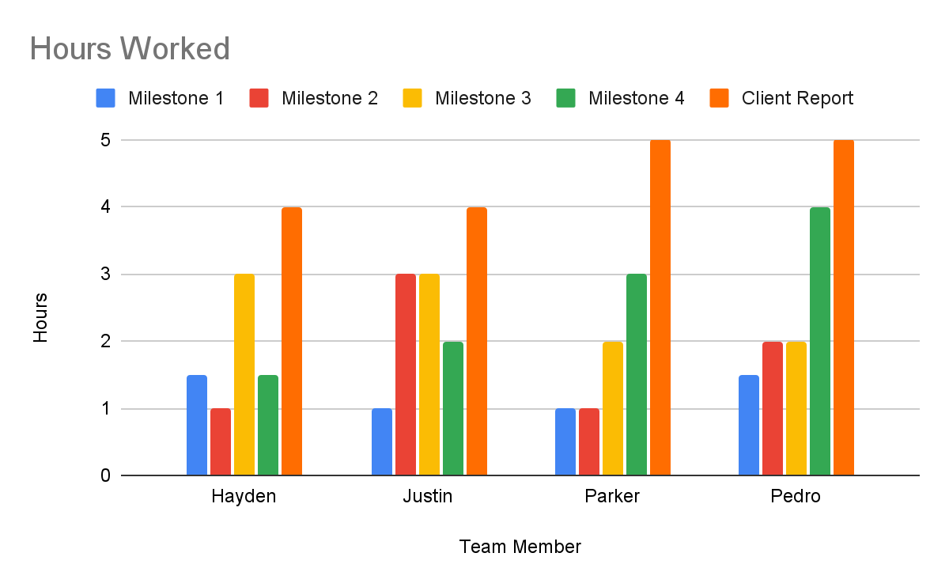

## Appendix B: Weighted Objective Chart Rubric

## Appendix C: Team Charter

Memorandum

To: Dr. Kate Skipsey

From: Hayden Dunstan, Justin Eng,

Parker DeBruyne, Pedro Augusto Gonçalves Gomes Amaral

Date: Mar 3rd, 2023

Subject: Team Charter; Milestone 1

1. Team Expectations

This is our team charter, detailing the expectations and criteria for our team conduct for the duration of the project and the firing mechanism in place if a team member consistently does not follow those criteria.

**Team Goal:** A grade of A- as a minimum, but higher if the team has extra time.

**Frequency of Meetings:** At least one per week but more if necessary .

**Expectation of Due Dates:** Soft due date for a decent draft two days prior to class due date.

**How We Resolve Disputes:** Talk as a group and try to identify issues before they get uncontrollable.

Table 1 shows the criteria by which we use to judge each team member's qualities:

| Criteria | Very good | Pretty Good | Acceptable | Unacceptable |
| --- | --- | --- | --- | --- |
| Scoring | 3 | 2 | 1 | 0 |
| Responsiveness | 6 hours | 12 hours | Up to 24 hours | More than 48 hours |
| Leadership / Accountability | Understands the needs of others, sets deadlines, and delegates work accordingly | Understands the project, delegates work, and sets deadlines appropriately | Understands what needs to be done for the project, and sets deadlines appropriately | Does not understand what is required to be done in the project. Only delegates work to others. |
| Communication | Clear, honest, assertive, empathetic, active listening | Open minded, impersonal, calm and adaptable | Disagrees professionally, expresses opinions and difficulties | Interrupts,  Rude,  Unprofessional,  Closed to opinions |
| Initiative | Regularly proposes and explores new ideas on their own | Occasionally proposes new ideas and volunteer to help with other’s | Does not propose their own ideas but volunteers to help with others’ | Like a potato, it does not do anything unless told to do so. |
| Productivity / Work Quality | Does the work they are expected to do and is able to help others | Does work as expected prior to deadline | Does meet deadline and quality, but just barely | Like a dead fish. Fails to meet deadlines and quality |
| Equitable share of tasks | Attempts to take as much work as appropriate | Either takes a bit too much or too little work | Does their share as given; does the bare minimum or excess | Fails to meet expected work amount or changes others’ |

*Table 1: Group expectations criteria*

2. Firing Mechanism

If a team member notices that another is not meeting some acceptable criteria, the issue should be discussed with the rest of the group. If everyone agrees, the team member in question is given a warning. Otherwise, the group would individually score said member based on the criteria described in Table 1. If the average of the score given out is under 10 points (out of a maximum of 18), the team member would also be given a warning for their behavior. A team member receiving 2 warnings for the same criteria or 3 warnings overall is grounds to proceed with their firing, which starts by bringing the issue to Dr. Skipsey.